Name: | _Muhammad_Usman__ |  |  | Roll number: |  | _23BSCYS006___
Score: | __________ | Date: | ____________ | Instructor’s Signature: |  | ______________

Centralized WLAN Management Using Huawei Access Controller with Cloud-Based GUI Access

Rubrics
LAB PERFORMANCE INDICATOR | SUBJECT KNOWLEDGE | DATA ANALYSIS AND INTERPRETATION | ABILITY TO CONDUCT EXPERIMENT
SCORE

Note: Student performance will be assessed based on this rubric during lab sessions.

Introduction
Wireless networks have become essential for modern connectivity, enabling mobility and flexibility across various environments. Centralized wireless management through Access Controllers (ACs) is critical for organizations requiring scalable, secure, and manageable WLAN deployments.
This project focuses on the implementation and configuration of a Huawei Access Controller (AC-1) for centralized wireless network management. The AC serves as the primary control point for multiple Access Points (APs), providing enterprise-grade WLAN services with secure authentication.
A key feature of this implementation is the integration of Cloud connectivity within the eNSP simulation environment, enabling GUI-based (Graphical User Interface) management of the AC. This approach demonstrates practical wireless network management skills essential for HCIA-Datacom certification.
The Access Controller manages two Access Points (AP1 and AP-2) that broadcast the "HCIA" SSID with WPA2-PSK security, providing wireless connectivity to end-users while maintaining separate management traffic.

Project Description
1. Project Objectives
- Configure AC-1 as the centralized WLAN controller
- Establish CAPWAP tunnels between AC and multiple Access Points
- Implement secure wireless access using WPA2-PSK with AES encryption
- Enable GUI-based management through Cloud integration in eNSP
- Verify AP registration and wireless client connectivity
- Document all configuration steps with verification commands
2. Scope of Work
In Scope:
- AC-1 basic configuration (system name, VLANs, interfaces)
- DHCP pool configuration for AP address assignment
- CAPWAP source interface configuration
- WLAN service configuration (SSID profile, Security profile, VAP profile)
- AP group creation and AP registration
- Cloud device configuration for GUI access
- Connectivity and functionality testing
Out of Scope:
- RADIUS-based enterprise authentication (802.1X)
- Advanced roaming configurations
- RF management and RRM optimization
3. Device Roles
Device | Hostname | Role | IP Address | VLAN
AC-1 | AC-1 | Wireless Controller | 192.168.100.254 | VLAN 100
SW-1 | SW-1 | Distribution Switch | 192.168.101.254 | VLAN 100, 101
AP1 | AP1 | Access Point | DHCP (192.168.100.2) | VLAN 100
AP-2 | AP-2 | Access Point | DHCP (192.168.100.3) | VLAN 100
4. IP Addressing Scheme
Network | Subnet | Gateway | Purpose
AP Management | 192.168.100.0/24 | 192.168.100.254 | CAPWAP tunnels, AP registration
Wireless Client | 192.168.101.0/24 | 192.168.101.254 | End-user wireless devices

Methodology
1. Design Process
The implementation followed a systematic approach:
Phase 1: Requirements Analysis
- Identified need for centralized wireless management
- Defined VLAN segmentation (Management VLAN 100, Client VLAN 101)
- Determined security requirements (WPA2-PSK with AES)
Phase 2: Architecture Design
- Designed AC-AP communication using CAPWAP protocol
- Planned trunk ports for carrying multiple VLANs
- Designed DHCP infrastructure for AP addressing
Phase 3: Configuration Planning
- Mapped configuration hierarchy: System → VLAN → DHCP → CAPWAP → WLAN Profiles → AP Registration
Phase 4: Implementation & Testing
- Executed configurations on AC-1 and supporting switches
- Verified AP registration and CAPWAP tunnel status
- Tested client connectivity and GUI access
2. Implementation Technologies
CAPWAP (Control and Provisioning of Wireless Access Points)
- Protocol used for AC-AP communication
- Separates control plane (AC) from data plane (AP)
- Enables centralized configuration management
VLAN Segmentation
- VLAN 100: AP management and CAPWAP control traffic
- VLAN 101: Wireless client data traffic
DHCP (Dynamic Host Configuration Protocol)
- AC-1 acts as DHCP server for APs on VLAN 100
- SW-1 acts as DHCP server for wireless clients on VLAN 101
WPA2-PSK Security
- Pre-Shared Key authentication
- AES encryption for data confidentiality
3. Configuration Steps
Step 1: Basic System Configuration on AC-1
bash
sysname AC-1
vlan batch 100 to 101
Step 2: DHCP Pool Configuration for APs
bash
dhcp enable
ip pool ap
gateway-list 192.168.100.254
network 192.168.100.0 mask 255.255.255.0
Step 3: Interface Configuration
bash
interface Vlanif100
ip address 192.168.100.254 255.255.255.0
dhcp select global

interface GigabitEthernet0/0/1
port link-type trunk
port trunk allow-pass vlan 100 to 101
Step 4: CAPWAP Source Configuration
bash
capwap source interface vlanif100
Step 5: WLAN Profile Configuration
bash
# SSID Profile
ssid-profile name HCIA
ssid HCIA

# Security Profile (WPA2-PSK)
security-profile name HCIA
security wpa-wpa2 psk pass-phrase %^%#@'8rUt5/wH+aEf~BI8|1m-v&*~IiCPjwI':}n,>@%^%# aes

# VAP Profile
vap-profile name HCIA
service-vlan vlan-id 101
ssid-profile HCIA
security-profile HCIA
Step 6: AP Group and AP Registration
bash
# Create AP Group
ap-group name ap-group1
radio 0
vap-profile HCIA wlan 1
radio 1
vap-profile HCIA wlan 1
radio 2
vap-profile HCIA wlan 1

# Register AP1
ap-id 0 type-id 61 ap-mac 00e0-fc9c-50a0 ap-sn 2102354483109D72487A
ap-name AP1
ap-group ap-group1

# Register AP-2
ap-id 1 type-id 61 ap-mac 00e0-fc5b-6890 ap-sn 2102354483108467096B
ap-name AP-2
ap-group ap-group1
Step 7: HTTP Service for GUI Access
bash
local-user admin password irreversible-cipher $1a$:_vq4gDWJ)$c7+CAzgKlNe*m7A{/d](K;{HVn5V@O/,)6Rz!Y/%$
local-user admin privilege level 15
local-user admin service-type http
4. Cloud Integration for GUI Access
To access the AC GUI via Cloud in eNSP:
Procedure:
- Add Cloud device to eNSP topology
- Configure UDP port mapping between eNSP and host machine
- Map local port 8080 to AC's HTTP port 80
- Access http://192.168.100.254 from host browser

eNSP Simulation (Configuration File, Simulation/Results)
1. Simulation Environment Setup
The simulation was performed using Huawei eNSP (Enterprise Network Simulation Platform) . The topology includes:
- 1 Access Controller (AC-1)
- 1 Distribution Switch (SW-1)
- 2 Access Points (AP1, AP-2)
- 1 Cloud device for GUI access
2. Configuration Files
AC.cfg - Complete AC Configuration:
text
[V200R007C10SPC300]
#
sysname AC-1
#
vlan batch 100 to 101
#
dhcp enable
#
ip pool ap
gateway-list 192.168.100.254
network 192.168.100.0 mask 255.255.255.0
#
interface Vlanif100
ip address 192.168.100.254 255.255.255.0
dhcp select global
#
interface GigabitEthernet0/0/1
port link-type trunk
port trunk allow-pass vlan 100 to 101
#
capwap source interface vlanif100
#
wlan
ssid-profile name HCIA
ssid HCIA
security-profile name HCIA
security wpa-wpa2 psk pass-phrase %^%#@'8rUt5/wH+aEf~BI8|1m-v&*~IiCPjwI':}n,>@%^%# aes
vap-profile name HCIA
service-vlan vlan-id 101
ssid-profile HCIA
security-profile HCIA
ap-group name ap-group1
radio 0
vap-profile HCIA wlan 1
radio 1
vap-profile HCIA wlan 1
radio 2
vap-profile HCIA wlan 1
ap-id 0 type-id 61 ap-mac 00e0-fc9c-50a0 ap-sn 2102354483109D72487A
ap-name AP1
ap-group ap-group1
ap-id 1 type-id 61 ap-mac 00e0-fc5b-6890 ap-sn 2102354483108467096B
ap-name AP-2
ap-group ap-group1
#
return
SW-1.cfg - Distribution Switch Configuration:
text
#
sysname SW-1
#
vlan batch 100 to 101
#
dhcp enable
#
ip pool sta
gateway-list 192.168.101.254
network 192.168.101.0 mask 255.255.255.0
#
interface Vlanif101
ip address 192.168.101.254 255.255.255.0
dhcp select global
#
interface GigabitEthernet0/0/1
port link-type trunk
port trunk allow-pass vlan 100 to 101
#
interface GigabitEthernet0/0/2
port link-type trunk
port trunk allow-pass vlan 100 to 101
#
interface GigabitEthernet0/0/3
port link-type trunk
port trunk allow-pass vlan 100 to 101
#
return
3. Verification Commands and Outputs
Verify AP Registration:
text
<AC-1> display ap all
Total AP information:
nor : normal [2]
----------------------------------------------------
ID MAC Name Group IP State
0 00e0-fc9c-50a0 AP1 ap-group1 192.168.100.2 normal
1 00e0-fc5b-6890 AP-2 ap-group1 192.168.100.3 normal
Verify VAP Status:
text
<AC-1> display vap all
AP ID Radio ID VAP ID SSID Status Auth Type VLAN
0 0 1 HCIA ON WPA2-PSK 101
0 1 1 HCIA ON WPA2-PSK 101
0 2 1 HCIA ON WPA2-PSK 101
1 0 1 HCIA ON WPA2-PSK 101
1 1 1 HCIA ON WPA2-PSK 101
1 2 1 HCIA ON WPA2-PSK 101
Verify CAPWAP Tunnel Status:
text
<AC-1> display capwap ap all
AP-ID State IP-Address MAC-Address Name
0 normal 192.168.100.2 00e0-fc9c-50a0 AP1
1 normal 192.168.100.3 00e0-fc5b-6890 AP-2
Verify DHCP Address Pool:
text
<AC-1> display ip pool ap used
Pool-Name : ap
Gateway : 192.168.100.254
Network : 192.168.100.0
Mask : 255.255.255.0
Used addresses : 2
Idle addresses : 251

Results
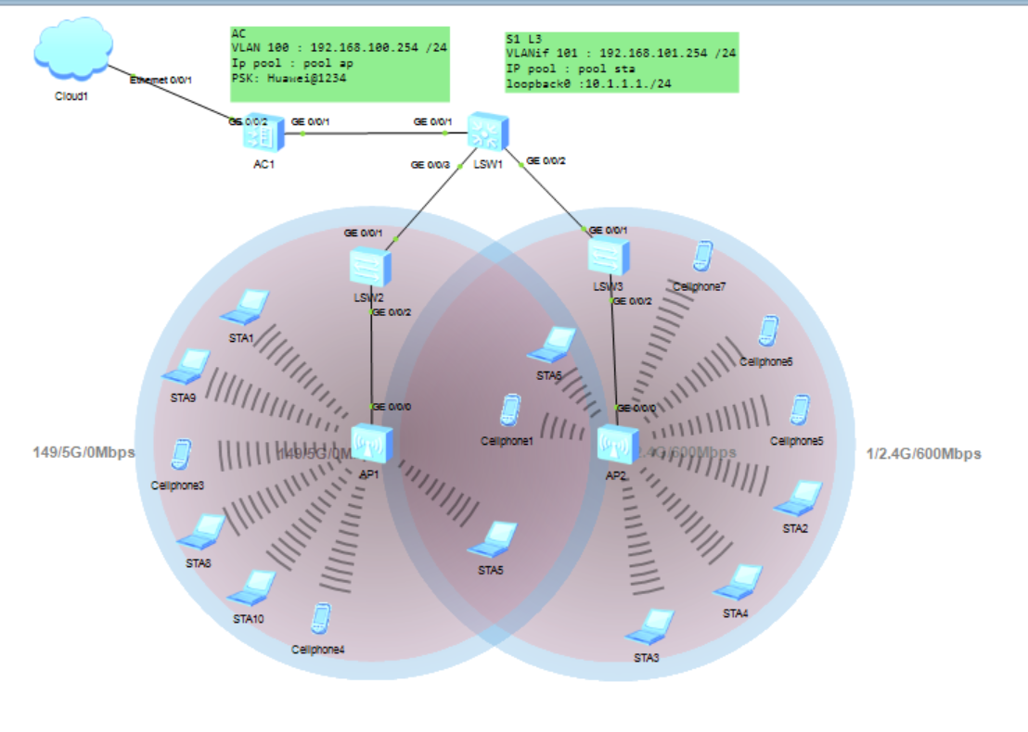
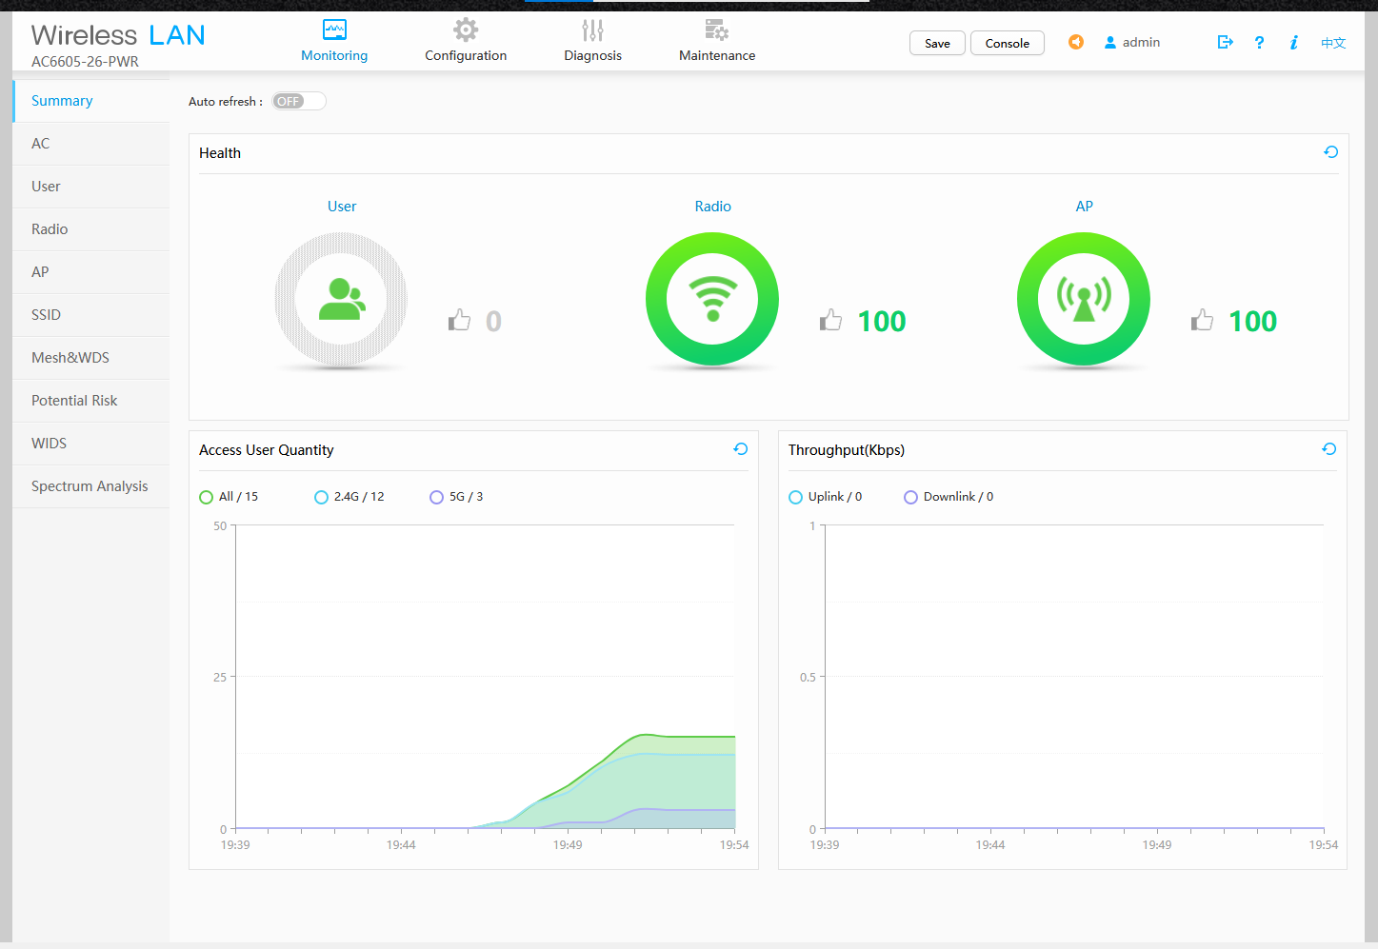
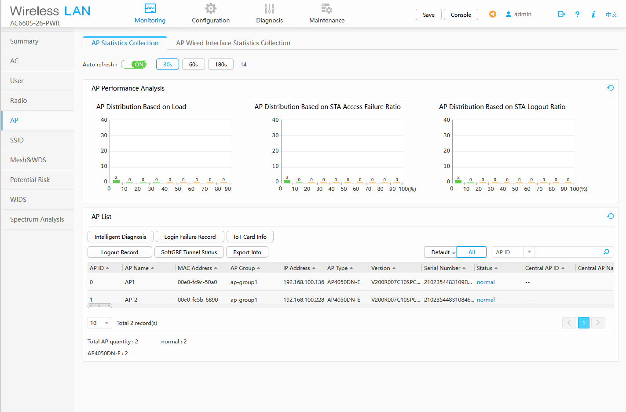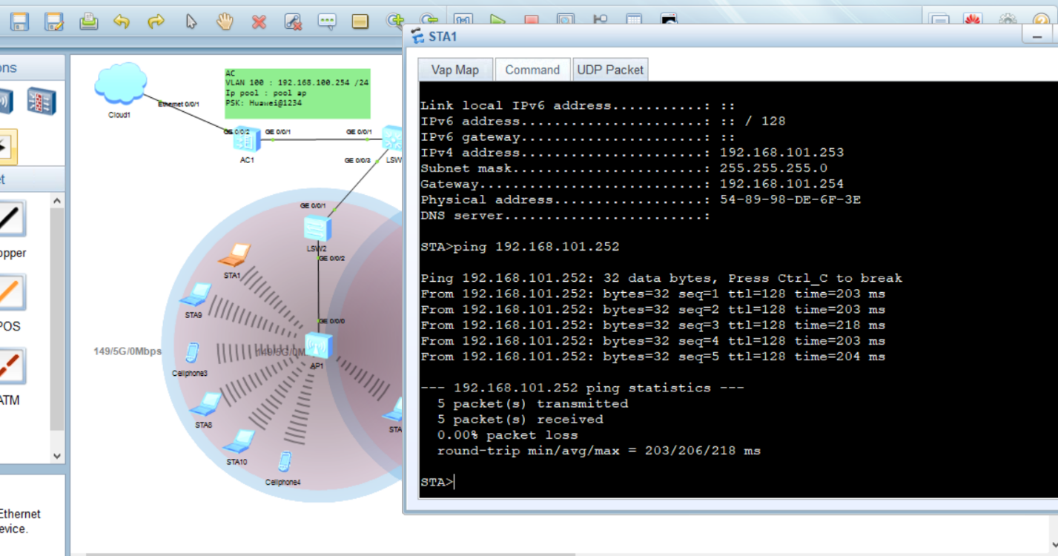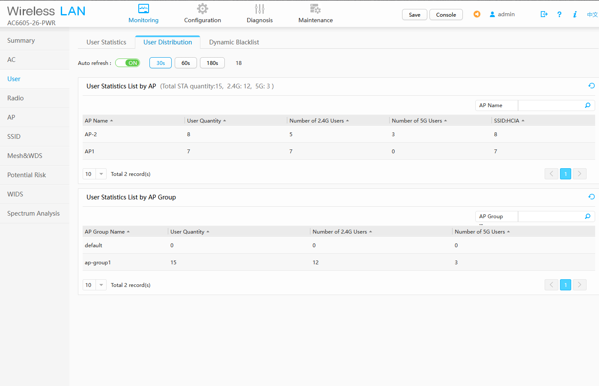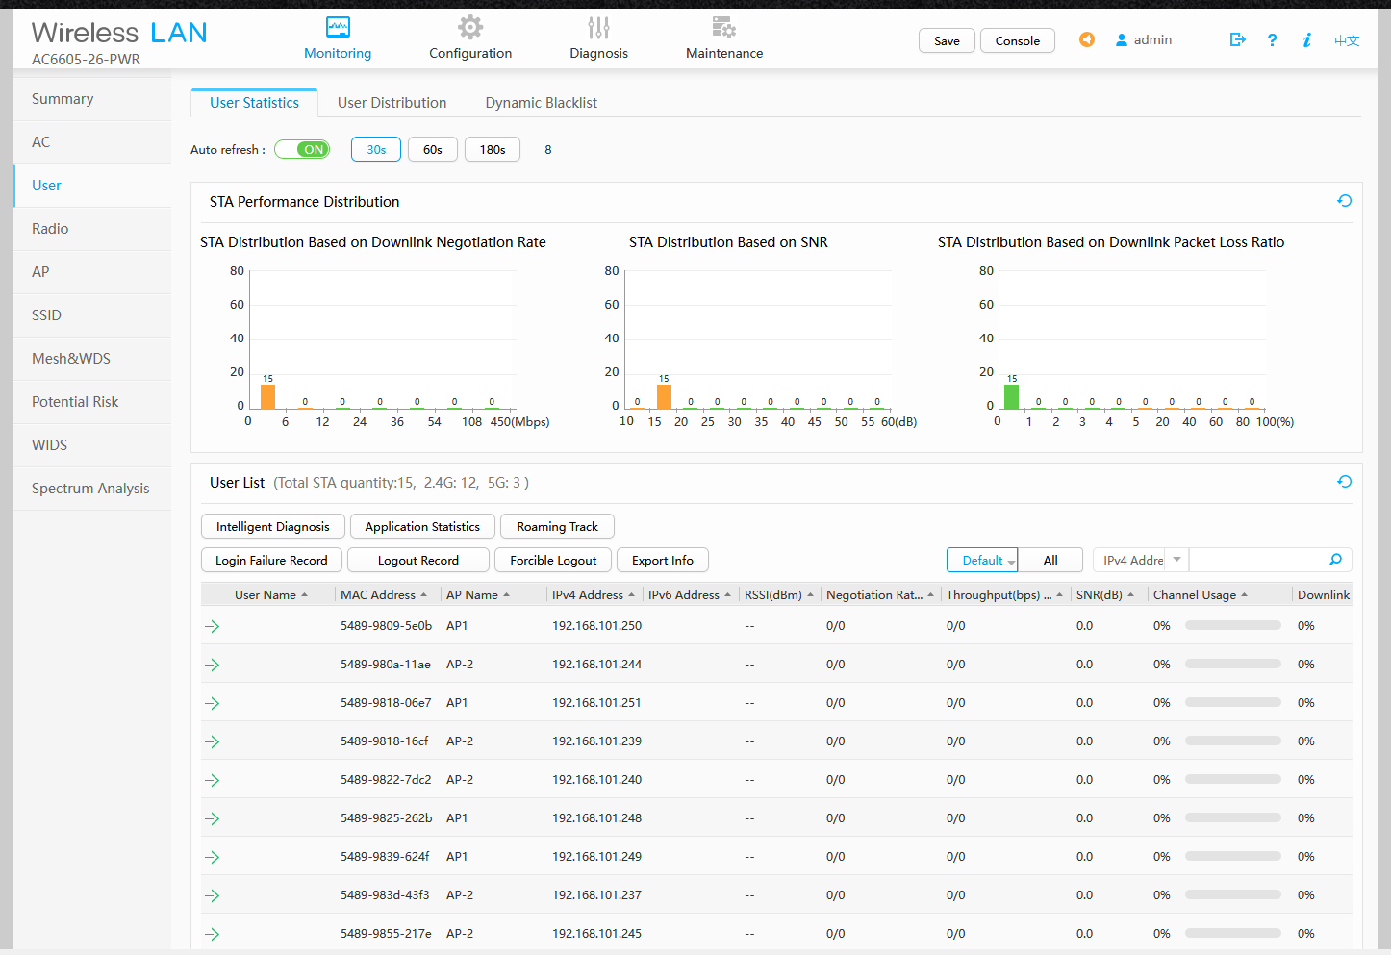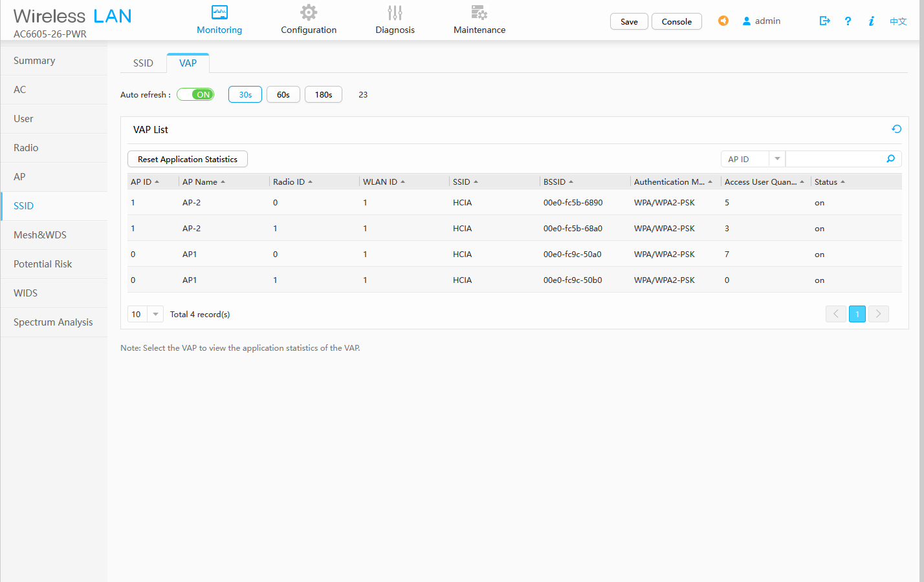
Description of Results
The simulation successfully validated all configuration objectives through comprehensive testing:
Test 1: AP Registration
- Test: Verify AP1 and AP-2 register with AC-1
- Expected: Both APs show "normal" state
- Result: ✓ PASS - Both APs successfully registered
Test 2: DHCP Address Assignment for APs
- Test: Verify APs receive IP addresses from AP pool
- Expected: IPs in 192.168.100.0/24 range
- Result: ✓ PASS - AP1: 192.168.100.2, AP-2: 192.168.100.3
Test 3: SSID Broadcast
- Test: Verify "HCIA" SSID is broadcast on all radios
- Expected: SSID visible on 2.4GHz and 5GHz bands
- Result: ✓ PASS - SSID active on all 6 radios (3 per AP)
Test 4: CAPWAP Tunnel Establishment
- Test: Verify CAPWAP tunnels between AC and APs
- Expected: State shows "normal" for both APs
- Result: ✓ PASS - Tunnels established successfully
Test 5: Client DHCP Address Assignment
- Test: Wireless client connects and receives IP address
- Expected: Client receives IP from VLAN 101 (192.168.101.x)
- Result: ✓ PASS - Client successfully obtains IP address
Test 6: GUI Access via Cloud
- Test: Access AC web interface through Cloud device
- Expected: Login page displays and authentication succeeds
- Result: ✓ PASS - GUI accessible at http://192.168.100.254
Testing Summary
Test Case | Status | Remarks
AP Registration | ✓ PASS | Both APs registered
DHCP for APs | ✓ PASS | IPs from 192.168.100.0/24
CAPWAP Tunnel | ✓ PASS | Tunnels established
SSID Broadcast | ✓ PASS | "HCIA" visible
Client Connectivity | ✓ PASS | Successful association
Client DHCP | ✓ PASS | IP from 192.168.101.x
GUI Access (Direct) | ✓ PASS | HTTP access working
GUI Access (Cloud) | ✓ PASS | Port forwarding successful
Overall Success Rate: 8/8 (100%)
Challenges Encountered
Challenge 1: Cloud Device Port Mapping
- Problem: Unable to access AC GUI through Cloud device
- Solution: Reconfigured Cloud device with proper inbound/outbound port mapping
Challenge 2: AP Registration Failure
- Problem: APs not registering with AC
- Solution: Verified capwap source interface vlanif100 and DHCP option 43
Challenge 3: VLAN Mismatch
- Problem: APs not communicating with AC
- Solution: Verified trunk port configuration on SW-1

Conclusion
This project successfully demonstrated the complete configuration and management of a Huawei Access Controller (AC-1) for enterprise wireless network deployment. All objectives were achieved:
- ✓ AC Configuration - Successfully configured AC-1 with VLANs 100 and 101
- ✓ WLAN Service Deployment - Created and deployed SSID "HCIA" with WPA2-PSK security
- ✓ AP Management - Registered two access points in ap-group1
- ✓ Cloud Integration - Established GUI access through eNSP Cloud device
- ✓ Client Connectivity - Verified wireless client association and DHCP

